Project 12-2: Exploring the National Vulnerability Database (NVD)
Estimated Time: 30 minutes
Objective: Use the NVD.
Description: The National Vulnerability Database (NVD) is managed by the U.S. government as a repository for vulnerability management data and contains software flaws, misconfigurations, product names, and their impacts. In this project, you will explore the NVD.
- Open your web browser and enter the URL https://nvd.nist.gov/ (If you are no longer able to access the site through this web address, use a search engine to search for “NIST NVD".)
- Click the plus sign next to General.
- Click FAQ.
- Click General FAQs.
- Read through the material. In your own words, how does the MITRE CVE compare with the NIST NVD? When would you use the CVE? When would you use the NVD? How frequently is the NVD updated? Is this often enough?
CVE provides the standardized naming and identification of vulnerabilities. NVD provides a more detailed analysis and scoring needed for risk management and security decisions. You would use the CVE when you need a way of identifying vulnerability or referencing a specific vulnerability. You would need an NVD when you need to assess the severity level of a vulnerability and are performing risk analysis tests. You would also need it to score a risk analysis using CVSS. NVD is updated daily and as soon as new CVEs are published. This is probably enough in most cases unless its something that is mission critical.

- Return to the home page by clicking the Back button as many times as necessary.
- Click the plus sign next to General.
- Click NVD Dashboard to view the latest information. Do the numbers surprise you? How does the number of vulnerabilities under the score distribution compare? Is that what you would have expected?
No, the numbers don’t surprise me about the CVEs Received and Processed. Under the score distribution most of the vulnerabilities are concentrated at the medium and high severity level and the smallest portion being low severity level. Yes, this is about what I expected.

- Scroll through the Last 20 Scored Vulnerability IDs & Summaries. Have you heard of any of these vulnerabilities? How will they be distributed to the public at large?
No, I have not heard of any of these vulnerabilities listed in the Last 20. It will be available to the public at large by making it accessible in the NIST Public Data Repository.

- Return to the home page.
- Click the plus sign next to General.
- Click Visualizations to display graphical information.

- Click Vulnerabilities – CVE.
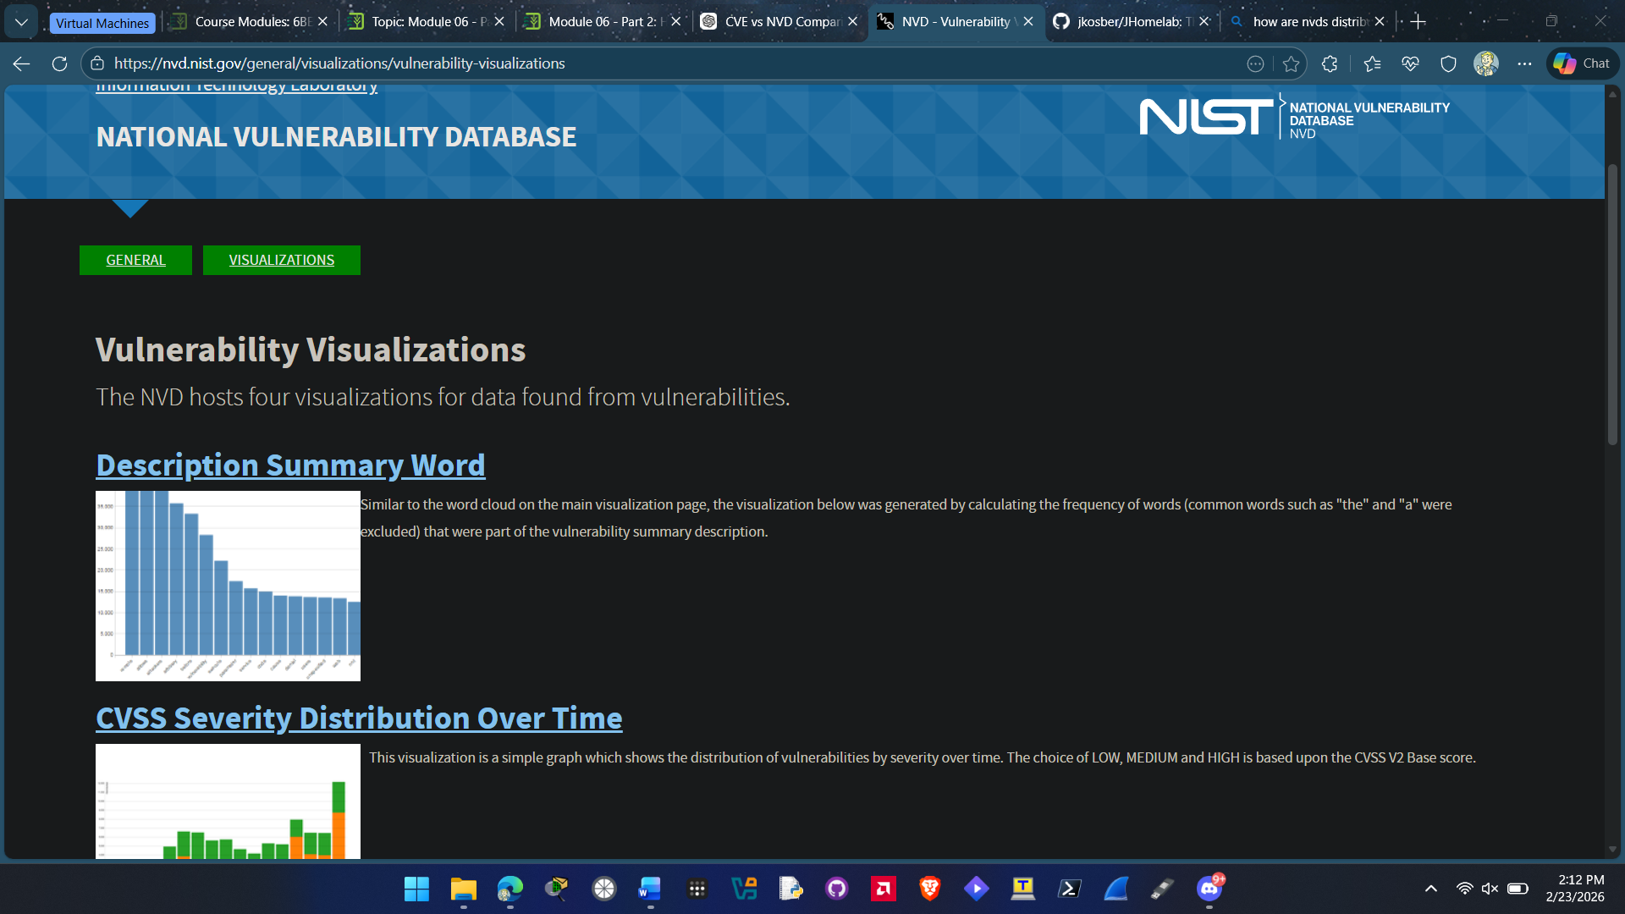

- Click Description Summary Word to display a bar graph of the most common words used as part of a vulnerability description. Hover over the three highest bars to view the three most frequent words used. Is this what you would have expected?
The three most frequently used words are vulnerability, allows, and before. No, I would have expected other keywords like attackers or similar.

- Return to the Vulnerability Visualizations page. Select each of the other graphs and study the information presented. How could a security professional use this information?
A security professional can use this information to figure out trends in frequency of words used in current vulnerability descriptions and also they can find out the distribution in severity levels in vulnerabilities over the years.

- Return to the NVD Visualizations page. Click Products – CPE. Which vendor has the highest number of total products that appears in the NVD? View other vendors by hovering over the bars. What do you find interesting about this distribution?
Cisco is the vendor with the highest number. The interesting part about this distribution that it’s a slow decline then the last half are around the same.

- Return to the home page by clicking the Back button as many times as necessary.
- Click the plus sign next to Other Sites.

- Click Checklist (NCP) Repository.
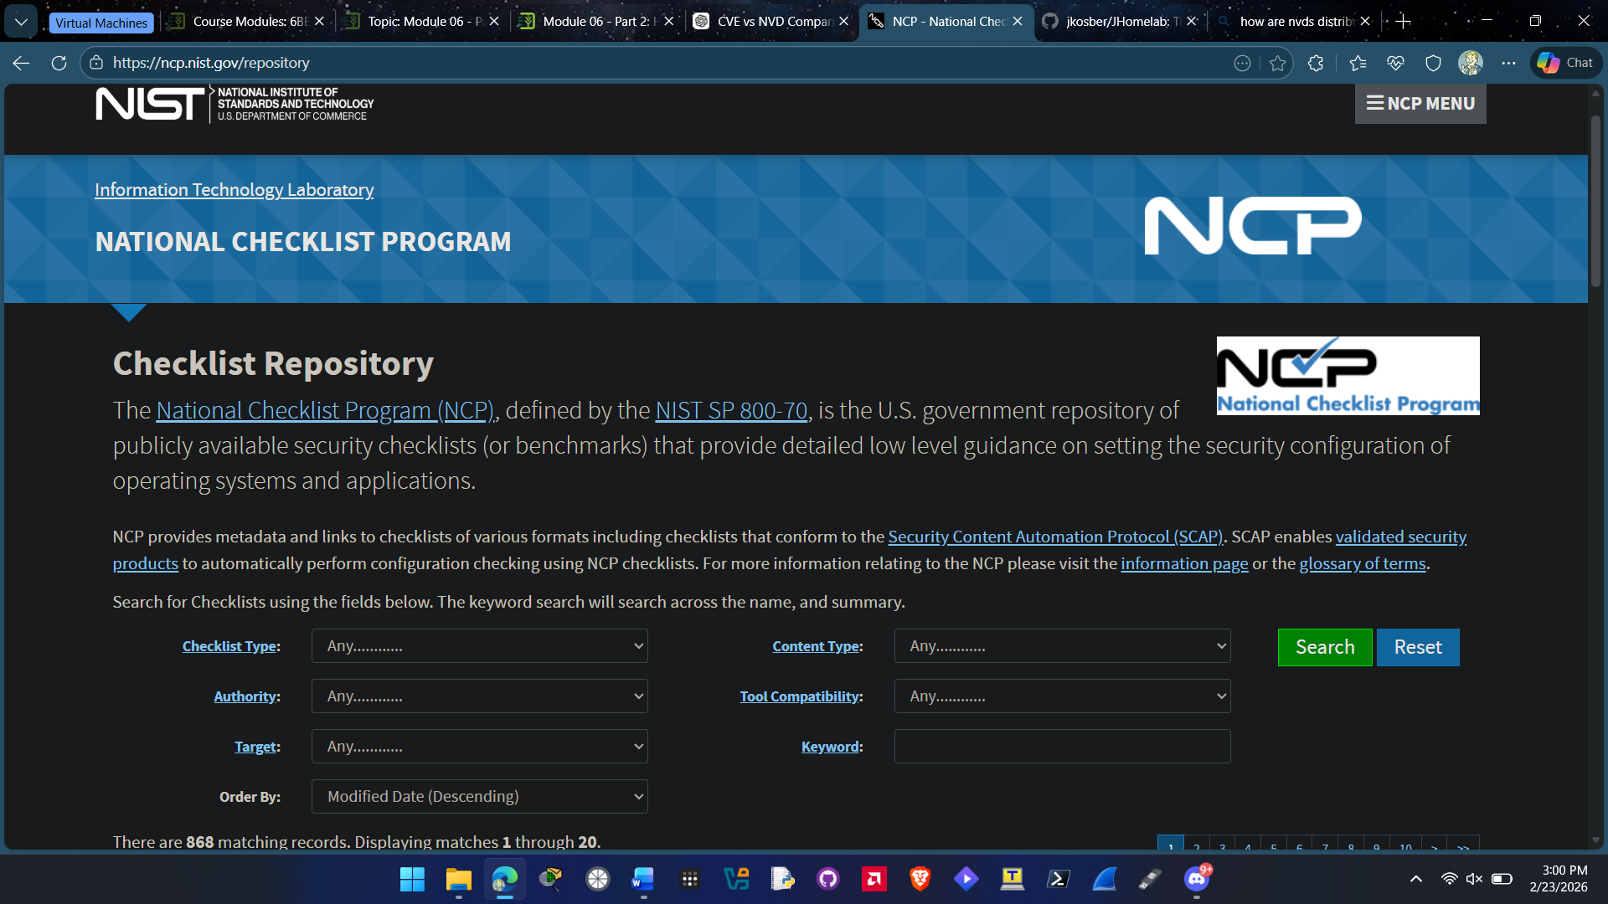
- This displays a form through which you can search for benchmarks/secure configuration guides. Select different parameters to view different guides, and then select one to view in detail. Is this information helpful?
Yes this information is helpful for security configurations

- Return to the home page by clicking the Back button as many times as necessary.
- Click the plus sign next to Search.
- Click Vulnerability Search.
- Enter passwords. How many vulnerabilities are found? Select several of these to read through the information.
2575 vulnerabilities were found when searching passwords.

- Select a different vulnerability to search the NVD database. How useful is this information?
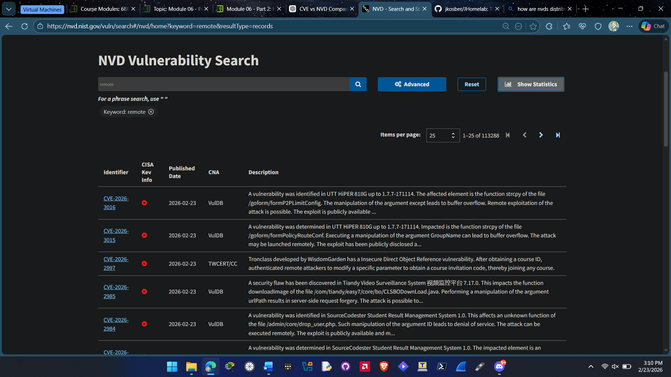This information is very useful it gives you information on new vulnerabilities depending on the keyword searched.

- Close all windows.

Criteria | Meets Requirements | Needs Improvement | Incomplete
Content | The assignment clearly and comprehensively addresses all questions in the assignment.  15 points | The assignment partially addresses some or all questions in the assignment.  8 points | The assignment does not address the questions in the assignment.  0 points
Organization and Clarity | The assignment presents ideas in a clear manner and with strong organizational structure. The assignment includes appropriate content, coverage of facts, arguments, and conclusions.  10 points | The assignment presents ideas in a mostly clear manner and with some organizational structure. The assignment includes appropriate content, coverage of facts, arguments, and conclusions.  7 points | The assignment does not present ideas in a clear manner or with a strong organizational structure. The assignment includes some appropriate content, but coverage of facts, arguments, and conclusions are not logically related and consistent.  0 points
Research | The assignment is based upon appropriate and adequate data collection and analysis of results from the activity or research from academically reliable sources.  5 points | The assignment is based upon adequate data collection and includes some analysis of results from the activity or research from academically reliable sources.  3 points | The assignment is not based upon appropriate data collection and includes no analysis of results from the activity or research from academically reliable sources.  0 points
Grammar and Spelling | The assignment has two or fewer grammatical and spelling errors.  5 points | The assignment has three to five grammatical and spelling errors.  3 points | The assignment has more than five grammatical and spelling errors, is incomplete, or is unintelligible.  0 points

